10.9 Render - Audio Rendering
Introduction 1
Options 1
Speaker 1
Options 2
Sound 2
Distance 2
Cone 3

Introduction

Audio can be rendered from the Render menu in the Info Editor.
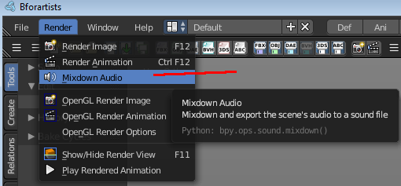

Options
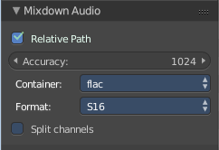
The options can be found downleft in the Save dialog.
Relative Path
Select the file relative to the blend-file.
Accuracy
Sample accuracy, important for animation data (the lower the value, the more accurate).
Audio Containers
See here.
Codec
Some Audio Containers also have option to choose a codec. For more information see here.
Split Channels
Each audio channel will be rendered into a separate file.

Speaker
The speaker object is used to give sound in the 3D View. After adding the object the various settings can be changed in the properties editor.

Options

Sound
Mute
Toggles whether or not the sound can be heard.
Volume
Adjust the loudness of the sound.
Pitch
Can be used to bend the pitch of the sound to be either deeper or higher.

Distance
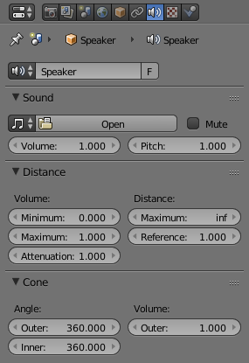
Volume
Minimum
Minimum volume, no matter how far the object is.
Maximum
Maximum volume, no matter how far the object is.
Attenuation
How strong the distance affects the volume.
Distance
Maximum
Maximum distance for volume calculation.
Reference
Reference distance at which volume is 100%.

Cone
Angle
Outer
Angle of the outer cone in degrees. Outside this cone the volume is the outer cone volume (see below). Between the inner and outer cone the volume is interpolated.
Inner
Angle of the inner cone in degrees. Inside the cone the volume is 100%.
Volume
Outer
Volume outside the outer cone.

